Case of I.C. v. Moldova
Easy to Read Summary of the Court’s Decision

What is this about?
This is about a woman with an intellectual disability who was treated badly. | 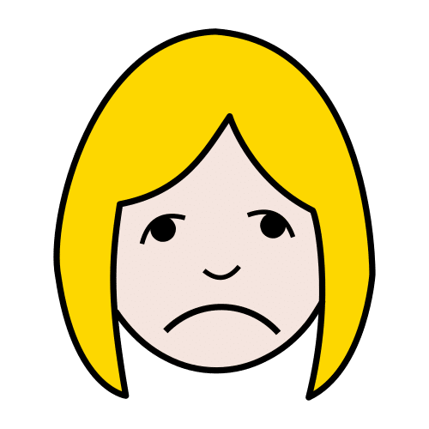

The woman's story
The woman is called I.C. in the court papers. | 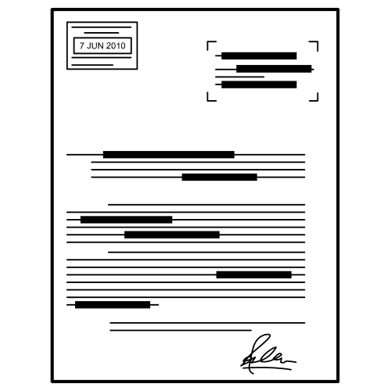
She grew up in a state institution because she was abandoned as a baby. | 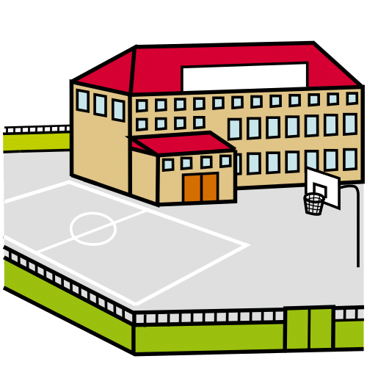
In 2013, a couple took her to live on their farm. | 
At the farm:  - She had to work very hard every day  - She took care of animals and cleaned  - She got almost no money  - The man sexually abused her  - She was treated badly | 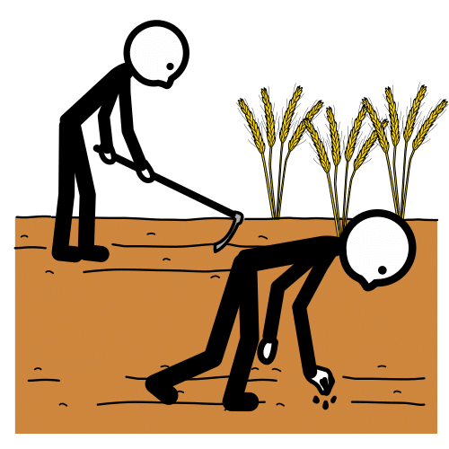
In 2018, she ran away and called a helpline for help. | 

What the court found
The court found that Moldova did not protect I.C. properly. | 
Moldova did not:
- Check if the family would be safe for I.C.
- Visit her regularly to make sure she was OK
- Give her support in the community
- Help her to make her own decisions
 | 
When I.C. reported the abuse, the police and courts:  - Did not listen to her properly  - Did not take her complaints seriously  - Did not give her extra help because of her disability | 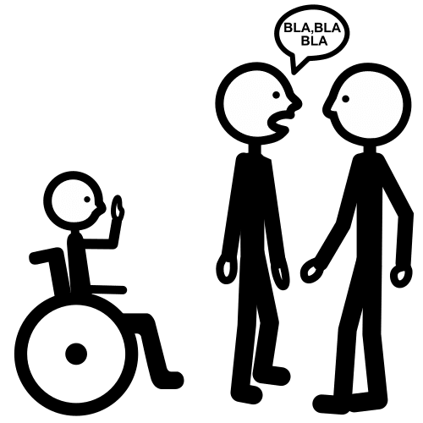

What should have happened
When people move out of institutions, they need:
- Proper support in the community | 
- Regular visits to check they are safe | 
- Help to make their own choices if they want it | 
- Someone to talk to if things go wrong | 

The court's decision
The court said that Moldova broke these human rights:
- The right to be free from forced work | 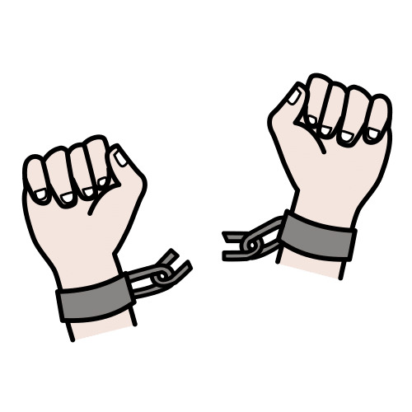
- The right to be free from inhuman treatment | 
- The right to be treated equally and not discriminated against | 

What happens now
The court ordered Moldova to:
- Pay money to I.C. for the harm she suffered | 
- Make better systems to protect people with disabilities | 
This case helps all people with disabilities know their rights. | 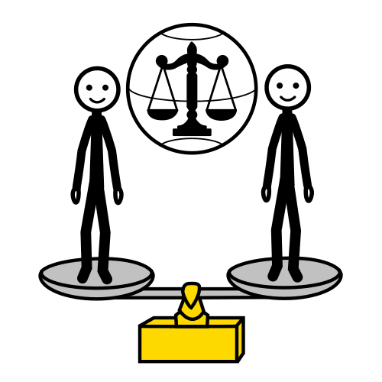

Where to get help
If you are being treated badly, you can:
- Talk to someone you trust  - Call a helpline  - Contact a disability organisation  - Speak to a social worker | 

