


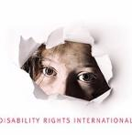

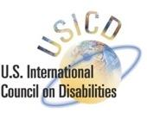

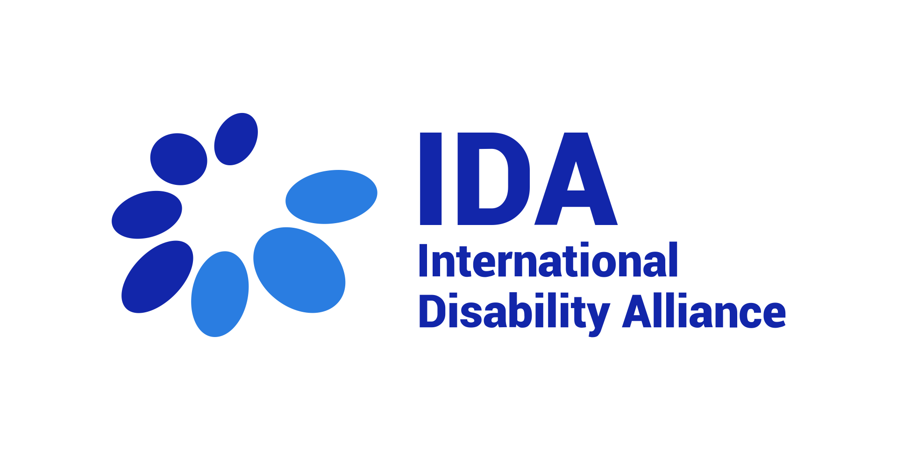





July 21st, 2021

Call to action:
Protect the right to family life & prevent institutionalization
for all children

The signatories to this call to action acknowledge the leadership of the United Nations Committee on the Rights of the Child and of the United Nations Committee on the Rights of Persons with Disabilities in their efforts to harmonize international human rights standards concerning children deprived of parental care.
This call to action seeks to contribute to a range of efforts worldwide to promote consistent interpretation and enforcement of international human rights law in respect of children with disabilities, including the activities of the committees mentioned and other stakeholders and in particular the preparations for a Day of General Discussion on Children’s Rights and Alternative Care scheduled to take place in September 2021 under the auspices of the Committee on the Rights the Child.

What we know today:

- All children need families – A growing body of scientific research shows that all children need families for their healthy emotional, cognitive and physical development. In a comprehensive review of the research literature, an international consensus statement adopted by researchers on child welfare concluded that “[g]roup settings should not be used as living arrangements, because of their inherently detrimental effects on the healthy development of children, regardless of age.”
- Evidence now exists showing that all children can live safely and thrive in families; all children with disabilities, no matter what their support needs, can and must be supported and accommodated to live in families.
- Most children have families and are placed in institutions due to poverty and/or disability and the stigma associated with disability; if legal protection and supports for families were available, new placements could be stopped.
- Millions of children remain in institutions and residential care around the world; it is likely that public and private funding will continue to be used to move children from large to smaller institutions (such as group homes), rather than to family-based care. This is why clarity and harmonization is needed on human rights standards.
- There is a high risk of specific forms of violence, abuse, and exploitation associated with non-family-based congregate group settings for children. Girls and non-binary children with disabilities are particularly at risk of such violence in these settings.
- Children with disabilities are often left behind in childcare reform programs; unless family support is guaranteed and protected, children with disabilities are at risk of remaining in large or small institutions, segregated from the community.

Guidance from international human rights mechanisms should be harmonized to strengthen protection of the right to family life. Consistent and harmonized messages are important to ensure governments, service providers, and donors take unified action to promote the right to family life for all children. To this end, efforts towards harmonized guidance and standards should:

- Explicitly acknowledge that the right to family life is only fulfilled for children when they grow up in an environment where they can form stable relations with a committed adult care-giver. Conversely, the right to family life cannot be fulfilled in any form of institution or non-family environment.
- Reflect that families may take different and diverse forms and may include a broad array of relationships, including married and unmarried parents, single parents, same-sex parents, adoptive families, kinship care, kafalah, sibling care, extended family, and substitute families or foster care.
- Strive to review and update previous standards, such as the UN Guidelines for the Alternative Care of Children, to reflect current scientific knowledge about the dangers of non-family-based congregate care and any kind of institutional or residential care placement.

Harmonized guidance and standards will have important benefits for all children, as they will contribute to:

- Strengthening the role of families and enhancing policies to support parents in the exercise of their child rearing responsibilities, preventing family separation and fostering inclusion and participation in the community.
- Protecting against the inherent dangers of institutionalization. Indeed, the right to family life is not respected nor fulfilled where the State places or acquiesces to the placement of any child in an institutional setting as their primary place of residence.
- Ensuring that all children enjoy the “right to be heard”, including children with disabilities in all care-related decisions, including but not limited to placement in care, care implementation, care review, plans to change alternative care settings or to leave alternative care, and in policy-related processes. Children should be provided with age-appropriate and disability-related support needed to understand all relevant information or to express their views. Disability must never be a reason to prevent a child from expressing their view or for not taking their view seriously.
The undersigned organizations call on the UN human rights mechanisms, States, international cooperation agencies, donors, and other stakeholders, in close consultation and with the active involvement of organizations of persons with disabilities, to:

- Urgently undertake every effort to support family-based care instead of large or small institutions; available resources should be used to support families and create more family-based placements -- not for building or expanding any new large or small institutions (whether they are called ‘residential care’, ‘group homes’, or ‘family-like units’, or similar). According to General Comment No. 5 on the right to live independently and be included in the community (2017) by the Committee on the Rights of Persons with Disabilities:
  - ‘For children, the core of the right to be included in the community entails a right to grow up in a family’ (para. 37).
  - ‘Large or small group homes are especially dangerous for children, for whom there is no substitute for the need to grow up with a family. ‘Family-like’ institutions are still institutions and are no substitute for care by a family.’ (para. 16(c)).
- Recognize that any placement of children in a residential setting outside a family should be considered as placement in an institution (UN Special Rapporteur on the Rights of Persons with Disabilities, Ending the Deprivation of Liberty on the basis of Disability (2019) A/HRC/40/54).
- Adopt measures to promote and enhance the development of support services for children with disabilities and their families to facilitate the adequate exercise of parental rights and responsibilities and to facilitate the inclusion of children with disabilities in community life. Governments must plan for phasing out institutions, including all forms of residential care and group homes. This includes:
  - adopting a moratorium on new admissions to institutions while immediately putting in place support to families of children at risk of institutionalisation;
  - preventing the construction or expansion of new institutions;
  - urgently developing, in consultation with and with the involvement of persons with disabilities, including children with disabilities, concrete plans to transition children currently living in such facilities to family-based care and to phase out institutions within the minimum period and on a publicly declared time frame.
- Take all possible measures to ensure the right to family life of children is protected during publicly declared states of emergency, including situations of natural disaster and humanitarian emergencies. Where the States have no option than to place children deprived of family care in a temporary non-family setting, family ties should be actively maintained and family life restored as soon as possible.
- Prevent and avoid undermining the universal right of all children to live and grow up with a family based on situations of family crisis and breakdown. States must invest in emergency support systems for extended kinship or foster care so that any child without parental care or experiencing abuse in the home can be immediately placed in another family setting that is safe and adequate. Neither states of emergency nor individual crisis placement decisions can be justified on the basis of disability or any other protected characteristic, in respect of the child or their primary caregiver.
- Prevent stigmatization and discrimination of children on the basis of disability, including by association, which are barriers to inclusion and deinstitutionalisation. States should adopt awareness measures on the rights of persons with disabilities (CRPD article 8), with a particular focus on the rights of children with disabilities, including on the fact that children with disabilities have the same right to family life as all children.
- Enhance accessibility of the built environment, transportation, information and communication, in particular of mainstream community environments, including through universal design. Successful elimination of large and small institutions will require a long-term commitment to making communities accessible to people with disabilities throughout the life-cycle.
- Enhance implementation of other human rights of children to prevent recurring to institutionalization:
  - Accessible, affordable and quality healthcare services play a vital role in facilitating social inclusion and supporting families. Inability to access healthcare services must never lead to a child's separation from their family. States must act to ensure the right to health for all children with disabilities and support their families with access to integrated multidisciplinary healthcare.
  - Failure to provide all children with the right to inclusive education at all levels, in their communities, cannot justify the use of boarding schools and other forms of institutional care for the purpose of exercising the right to education.
- Ensure and facilitate the right to access justice and to gain comprehensive redress and the right to be heard in all care-related decisions to all children who experience deprivation of their right to family life.
- Develop and ensure access to support services in the community, including personal assistance, as well as peer support, for young persons with disabilities in their transition to adulthood. Young persons with disabilities must also be provided with opportunities to choose where and with whom to live, in line with Article 19 CRPD, and taking into consideration that independent living arrangements are defined in CRPD Committee General Comment No. 5 as “life settings outside residential institutions of all kinds”.

Signatories:

Autism Europe
Disability Rights International
ENIL - European Network for Independent Living
Inclusion International
International Disability Alliance
International Federation for Spina Bifida and Hydrocephalus (IF)
Validity Foundation
Women Enabled International
U.S. International Council on Disabilities
Stahili
Lori E. Talsky Center for Human Rights of Women and Children at Michigan State University College of Law

Co-signatories:

Amal Alliance
Asociación Azul
ASTRA Anti-trafficking Action
Autistic Minority International
Belgrade Centre for Human Rights
Bina Foundation Nigeria
Candle of Hope Foundation
Center for Inclusive Policy
Center for Public Representation
Centre for Independent Living - Sofia, Bulgaria
Center for Outcome Analysis
Centre Living Upright
Child Rights Centre
Coalition for monitoring child rights in Serbia (Child Rights Centre, Užice Child Rights Centre, Belgrade Centre for Human Rights, ASTRA — Anti Trafficking Action and Center for Social Policy)
Colectivo Vida Independiente de Guatemala
Collective Impact
Congo Handicap
Disability Law and Policy Program of Syracuse University College of Law
"Disability Rights Agenda" NGO - Armenia
Disabled Peoples' International Europe DPI-E
DRRA
Educom+ (The community for the plus in education)
Family Kolping Prykarpattya
Fédération Togolaise des Associations de Personnes Handicapées (FETAPH)
FemPlatz
Fundacion transformar es preciso
Fundația de Abilitare Speranța, Timișoara
GatherBuildWork
Georgian Academy of Childhood Disability
GERAKAN PEDULI DISABILITAS DAN LEPRA INDONESIA (GPDLI)
Global Campaign for Education
Global Campaign for Education-US
GlobalPartnersUnited
Home Free
i-living - the Independent Living Organization of Greece
International Charity Partnership for Every Child
Keepers of the Circle
Korean Disability Forum
Malta Federation of Organisations Persons With Disability (MFOPD)
Matifadza Hydrocephalus Care Trust
Mental Disability Rights Initiative MDRI-S
National Association for Rights Protection and Advocacy
Network of Organizations for Children of Serbia MODS
Partnership for Early Childhood Development & Disability Rights (PECDDR)
Pennsylvania TASH ("PennTASH")
Prijatelji dece Srbije (Friends of Children of Serbia)
Redesfera Latinoamericana de la Diversidad Psicosocial
Samantha’s Law
Social Synergy
SPOON
Support Organization of Parents with Disabilities (SOPADI)
TASH
The Arc of Northern Virginia
The Delia Foundation
The Spectrum
Tushinde Children's Trust
Uganda Society for Disabled Children
Ukrainian Child Rights Network
Union of Disabled People Organisations of Azerbaijan
Uzice Child Rights Centre
Vida independiente Andalucía

Individual endorsements:

Áine Kelly-Costello, disability campaigner, European Network on Independent Living volunteer
Amalia Gamio, Independent expert in human rights of persons with disabilities
Ana Laura Aiello, researcher
Andrea Parra, Latin American Network on Art. 12
Angharad Beckett, PhD, FRSA, Professor of Political Sociology and Social Inclusion, Joint Director of the Centre for Disability Studies, University of Leeds, UK
Anna Lawson, PhD, Professor of Law, Joint Director of the Centre for Disability Studies, University of Leeds, UK
Brendan Boland, Asia Foundation
César Giménez Sánchez
David Geist
Eric A. Friedman, Global Health Justice Scholar, O'Neill Institute for National and Global Health Law, Georgetown University Law Center
Franke James
Helen Irobo
Jaakko Leppänen
Joan Kaufman, PhD, Professor of Psychiatry, Johns Hopkins School of Medicine, Director of Research, Center for Child and Family Traumatic Stress, Kennedy Krieger Institute
Johanna Smits
Lucy Baxter
Margaret Nyambura Mburu- O'Neill Institute for National and Global Health Law
Marilyn Long
Matteo Menozzi
Milica Mima Ruzicic – Novkovic
Mónica Marcela Cortinez, Persona con discapacidad baja Visión
Mr.Dayanidas Sudhakar
Nigeria National Association of the Deaf, Jigawa State chapter
Rados Keravica, Early-Stage Researcher, University of Leeds, Centre for Disability Studies
Scott F. Nolan, Massachusetts, USA
Yusuke Onoe

and 5 anonymous endorsements

Mary Dozier, Joan Kaufman, Roger Kobak, Thomas G. O’Connor, Abraham Sagi-Schwartz, Stephen Scott, Carole Shauffer, Judith Smetana, Marinus H. van IJzendoorn, and Charles Zeanah, Consensus Statement on Group Care for Children and Adolescents: A Statement of Policy of the American Orthopsychiatric Association, 84 American Journal of Orthopsychiatry 219-225 (2014). See further discussion in Section III infra.

